Which of the pair shows isomorphism?
A. $CaCO_{3} and NaNO_{3}$
B. $ZnSO_{4} and CaCO_{3}$
C. $NiSO_{4} and AgNO_{3}$
D. None of these
ANSWER: A
Which of these have the same empirical formula?
A. $NaF and MgO$
B. $NaNO_{3} and CaCO_{3}$
C. $ZnSO_{4}and NiSO_{4}$
D. All of these
ANSWER: D
$NaF$ and $MgO$ show
A. Isomorphism
B. Polymorphism
C. Allotropy
D. isotropy
ANSWER: A
Isomorphic substances have
A. some physical and chemical properties
B. same physical and different chemical properties
C. different physical and same chemical properties
D. Different physical and chemical properties
ANSWER: D
Isomorphic substances have the same
A. Empirical formula
B. molecular formula
C. both A&B
D. none of them
ANSWER: A
Which of the following is a Pseudo solid?
A. $CaF_{2}$
B. Glass
C. NaCl
D. Diamond
ANSWER: B
The constant temperature at which the solid and liquid phases of a substance are in equilibrium is called:
A. Freezing point
B. Melting point
C. Critical temperature
D. Transition temperature
ANSWER: D
When physical properties of crystals are different in different direction. The property is called:
A. Symmetry
B. Isotropy
C. Anisotropy
D. None of above
ANSWER: C
The state of matter that possesses a definite arrangement of particles are called:
A. Gas
B. Liquid
C. Solid
D. Plasma
ANSWER: C
A solid in which the constituent structural units are arranged in a definite geometrical configuration characteristics of the substance is known as:
A. Amorphous solid
B. Crystalline solid
C. Pseudo solid
D. Super cooled liquid
ANSWER: B
Which is not a characteristic of crystalline solids?
A. They undergo a clean cleavage
B. They are true solids
C. They are isotropic
D. They have sharp melting points
ANSWER: C
Which of the following is a characteristic of amorphous solid?
A. They are true solids
B. They have sharp melting points
C. They undergo clear cleavage
D. They are isotropic
ANSWER: D
Solids are classified as ___________
A. crystalline and ionic solids
B. metallic and amorphous solids
C. molecular and covalent solids
D. crystalline and amorphous solids
ANSWER: D
Which of the following represents amorphous solid?
A. 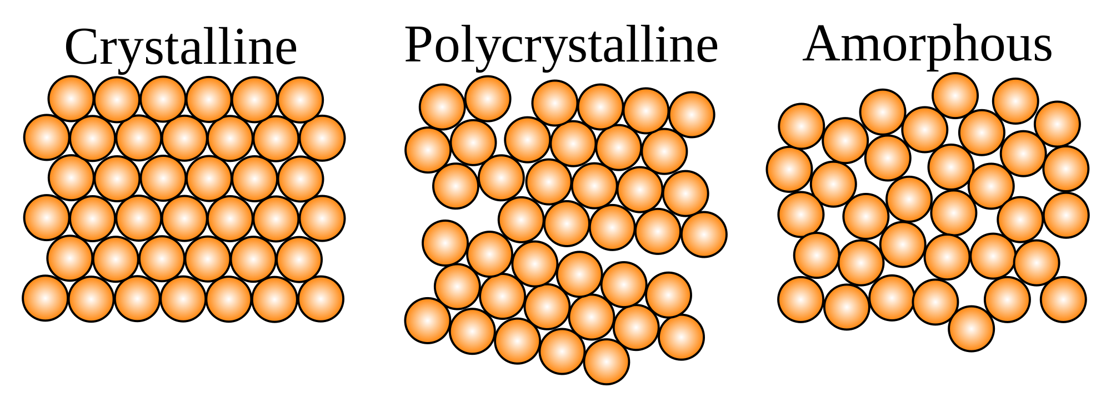
B. 
C. 
D. None of these
ANSWER: C
It is an example of crystalline form of carbon.

A. 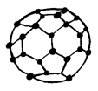
B. 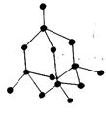
C. 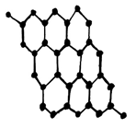
D. All of these
ANSWER: D

